Literature Review

Shift From Religion and Measuring “Nones”

Over time, social scientists have noticed a shift away from religion (Weber 2002). People are identifying less with traditional religious sects which suggests a general trend towards non-religious affiliation (Swatos and Christiano 1999). This has presented itself with an opportunity to find new ways to measure the religiously unaffiliated or religious “nones.” This has not been without its challenges. Finding new ways of measuring the religiously unaffiliated has been difficult mainly because the standard ways of asking about religion simply do not apply to the religiously unaffiliated which makes it difficult for them to answer (Cragun 2019). Scholars have been looking at how we should conceptualize religious “nones” (Baker and Smith 2015; Zuckerman et al. 2016). They have identified four main types of secular people (Baker and Smith 2015). This suggests that these groups require deeper analysis, and require new measuring techniques and a shift in religious identity politics study.

Measurement Difficulties

This shift in measurement has been difficult and measuring religious identity, in general, is challenging. Issues like respondents overstating their commitment to a religious affiliation, or not belonging to that group indicate higher numbers than exist and creates small, but notable differences in results (Caplow 1998; Kohut et. al 2001; Smith and Kim 2007). In general, these surveys neglect to measure the secular respondents because they only look at how religious people are, not how religious they are not (Hall, Meador, and Koenig 2008; Koenig and Meador 2009; Hwang, Hammer, and Cragun 2011). Previously conducted research attempted to solve these measurement problems through various types of survey questions. Smith and Kim are an example of this, where they explore the nuances of Protestant Christians (Smith and Kim 2005). They note that it is difficult because all surveys measure it differently, but also because if surveys mention a plethora of world religions, it is likely that respondents choose one (Smith 1991). This is less true if the questions are open-ended (Smith 1991). They also run into issues of respondent’s choosing answers that they believe will please the survey administrator through social desirability bias (Nederhof and Zwier 1983). This is true with any survey, across fields, that have questions regarding morality or self-assessment (Karp and Borckington 2005; McGuire 1968; Nederhof 1985; Nederhof and Zwier 1983; Streb et al. 2007). Topics like religion, sexual habits, and drug use lend themselves to this type of bias. Overstating their church attendance is a prime example of this (Hout and Greely 1998; Presser and Stinson 1998; Woodberry 1998). It is especially evident by Hout and Greely’s study in which the number of respondents saying that they attended church weekly did not correspond with the amount of people in the pews on Sundays in Ashtabula County, Ohio (Hout and Greely 1987). Other research found that the general discrepancy was somewhere between 16 and 20 percentage points (Hadaway et al. 1993, 1998). Attempts at measuring the religious “nones” have presented with equal difficulties and have not grasped the importance. This has been broached by looking at time series data of people and their religious affiliation over time, but only looked at how they move in and out of that group (Lim et al. 2010; Hout 2017). However, these studies do not look specifically at the measuring techniques of outside groups.

Importance of Measurement

The importance of this can also be seen in looking at the effects of not having a secular option. Noting that since the first religious question in the United States Census in 1957, there has been a neglect of the religiously unaffiliated (Good 1959). This was also evident in other surveys from around the same time, however, the secular respondents were lumped in together with other groups to equal 100, which negated it as a group for analysis (Svalastoga 1965; Vernon 1968). This means that for nearly six decades the religiously non-affiliated were essentially ignored, and neglected as a group for analysis. This is evident from research that looked at Gallup and GSS polls and found that the GSS had a larger group of “nones” than the Gallup poll because it had a “no religion” option (Hout and Fischer 2002). This suggests that they have always existed, but have not been analyzed or accounted for in typical survey practice. It has also changed the way we qualitatively look at religious affiliation and “nones.” McCaffree discusses the struggle between describing religiosity as a pattern of behavior or a belief system (McCaffree 2017). For example, the idea that people simply believe in a higher power and religious individualism (Bellah et. al 2007). It has also been described as an invisible religion, or non-doctrinal (Machalek and Martin 1976; Yinger 1969). Regardless, the religious “nones” have changed the way we look at religious identity politics as a whole, and how we view people beyond a survey question. Schwadel also discusses the importance in his work, noting that having no religious affiliation changes the way people move through the world, and how it alters their political views and participation (Schwadel 2020).

Importance of Atheism Measurement

The above research and articles suggest that measuring the religious “nones” are important in understanding religious identity politics. What has not been properly discussed is how atheists fit into this equation, and how we conceptualize and measure their identification. Cragun began this work with his piece, where he delved into what groups are within the non-religious (Cragun 2019). He asserts that many questions on religion in surveys contain questions that are impossible for the non-religious to answer, and this practice keeps us from understanding the separate non-religious sects. Current works have neglected to look at how the aspects of religiosity, like belief, behavior, and belonging, work for non-religious people (Lee 2014; Schnell 2015). For example, deciding between believing or belonging, or double-barrelled identification questions can force secular individuals into a religious category that they do not belong in (Converse 1986; Cragun 2016; Day 2011). This divide works both ways, as not all nonreligious people are atheists (Kosmin et al. 2009; Lee 2014). In addition, Cragun suggests that Atheists differ from other non-religious groups, through their belief in science, rejection of the supernatural, and criticism of other religions, and need to be studied apart from the group (Cragun 2014). Overall, Cragun suggests that the way the questions are formed in Gallup and other high-profile surveys force respondents into categories that in turn under measures their existence, both limiting our understanding of the group qualitatively and quantitatively (Cragun 2019).

The Cooperative Congressional Election Survey inadvertently offered researchers a unique insight into how atheists think about their place in the religious landscape of the United States when they did not include that option in the 2010 wave of their large, nationwide survey. If the option of “atheist” doesn’t exist on the survey, one would assume that this group of people would choose an identity that is closer in proximity, such as “agnostic” or “nothing in particular.” However, by reducing the number of “none” options from the three to two, that may nudge people away from choosing a religious non-affiliation and drive some potential atheists back into the Protestant or Catholic fold. Trying to understand the decision-making process that atheist navigated during this survey will be the focus of this research.

**Data**

The Cooperative Congressional Election Study (CCES) began as a project out of Harvard University in 2006. The survey became popular quickly because of its federated style. For a fee, a team of researchers could add a battery of questions to the instrument which would be asked to one thousand respondents, while those one thousand respondents would also be asked a larger set of core questions related to basic demographic, political matters, as well as questions about various aspects of religiosity. Because of the open source nature of the project, it became easy for dozens of research teams to sign on to the project, therefore the overall sample size began to far surpass most other surveys that are publicly available. For instance, the 2008 wave had 32,800 respondents. That jumped to 55,400 respondents in 2010, and to 64,600 in the sample in 2016. The survey is conducted through an online process which is facilitated by the polling firm YouGov using their pre-collected panels.

What is particularly helpful for students of American religion is that the CCES includes a number of questions related to all aspects of religiosity, but there is an especially robust battery of questions focused on religious belonging. The CCES adopted the Pew Research Center’s approach to measuring religion, which begins with a broad question that asks, “What is your present religion, if any?” That is followed by twelve different choices: Protestant, Catholic, Mormon, Orthodox, Jewish, Muslim, Buddhist, Hindu, Atheist, Agnostic, Nothing in Particular, and Something Else. However, something curious happened in the 2010 wave of the CCES – the survey did not give respondents the option of choosing “atheist.” It is simply missing from the data. While, on the surface, this looks like a mistake – it actually provides an interesting data puzzle for researchers – is it possible to reverse engineer the data to find the atheists in the 2010 wave?

**What is the second choice of atheists?**

A good starting point is to get a grasp on how the overall distribution of the sample shifted from the 2010 wave compared to the rest of the CCES samples from 2008-2018. To do that we calculated the share of the population that fell into each of the twelve religious categories in the seven waves in the CCES using the appropriate weights for each survey that were provided by the authors of the CCES. The 2010 wave is highlighted in a different color so it can be easily distinguished from the rest of the sample. In total this data represents 378,156 total respondents to the CCES.

Using the rest of the CCES trend lines, what share of the 2010 wave of the CCES should we expect to have chosen the atheist option? While 3.4% of the population were atheists in 2008, that had jumped to 4.3% by 2012 and then steadily rose form that point to reach 6% by 2018. If we assume that the proportion of atheists in the 2010 wave was halfway between 2008 and 2012, then we can assume that about 3.8% of the population in the 2010 CCES were atheists, which represents about 2100 total respondents.

It’s also important to point out that there is aberration in the 2008 data surrounding Protestant Christians. They were just 30.2% of the sample in 2008, which seems to be a dramatic outlier compared to the rest of the survey which pegs Protestants between 37-42% of the population. At the same time the “something else” category was 21.3%, which is fifteen percentage points higher than the typical outcome. Because of these aberrations it’s not possible to detect whether atheists chose one of these two categories at a higher rate. Instead, we turn our attention to some of the most likely landing spots for potential atheists: agnostic or nothing in particular.

It does appear the trend for agnostics does see a bit of an outlier in 2010. While in 2008 they were 4.5% of the population, and that had climbed to 5% by 2012, then the 5.2% figure reported in 2010 seems to be somewhat above the trendline. Although, admittedly, this outlier is not substantively large, it would appear that there were not a huge rush of atheists choosing the agnostic option instead. At the same time, the nothing in particular category does see a significant increase in 2010 compared to 2008 or 2012. While 14.4% of the population indicated that they were nothing in particular in 2008, that jumped 4.4 percentage points in 2010 to 18.8%, but then declined to 17.4% in the 2012 wave. In the rest of the series, there is no example of any religious groups increasing in size by four percentage points in one wave. If we can assume consistent growth between waves, then the nothing in particular category would have been 15.9% in 2010. That 2.9 percentage point difference likely contains a bulk of the atheists who chose it as a backup option.

In terms of other groups, it does appear that there was a possibly small increase in the share of Catholics. In 2010, there were 21% of the sample compared to 20.7% in 2008 and 19.1% in 2010. Although the share overall portion of Catholics in the population stayed relatively stable from 2008 through 2016. The only other instance where there could be a possible increase is among people choosing the Jewish option. In 2010, 2.4% of respondents chose the Jewish option, which was a jump of about half a percentage point form 2008 and 2012. It’s seems possible that people who were ethnically Jewish, but had atheist religious beliefs fell back to their ethnicity in 2010 when their religious preference was not an option.

**Figure 1**

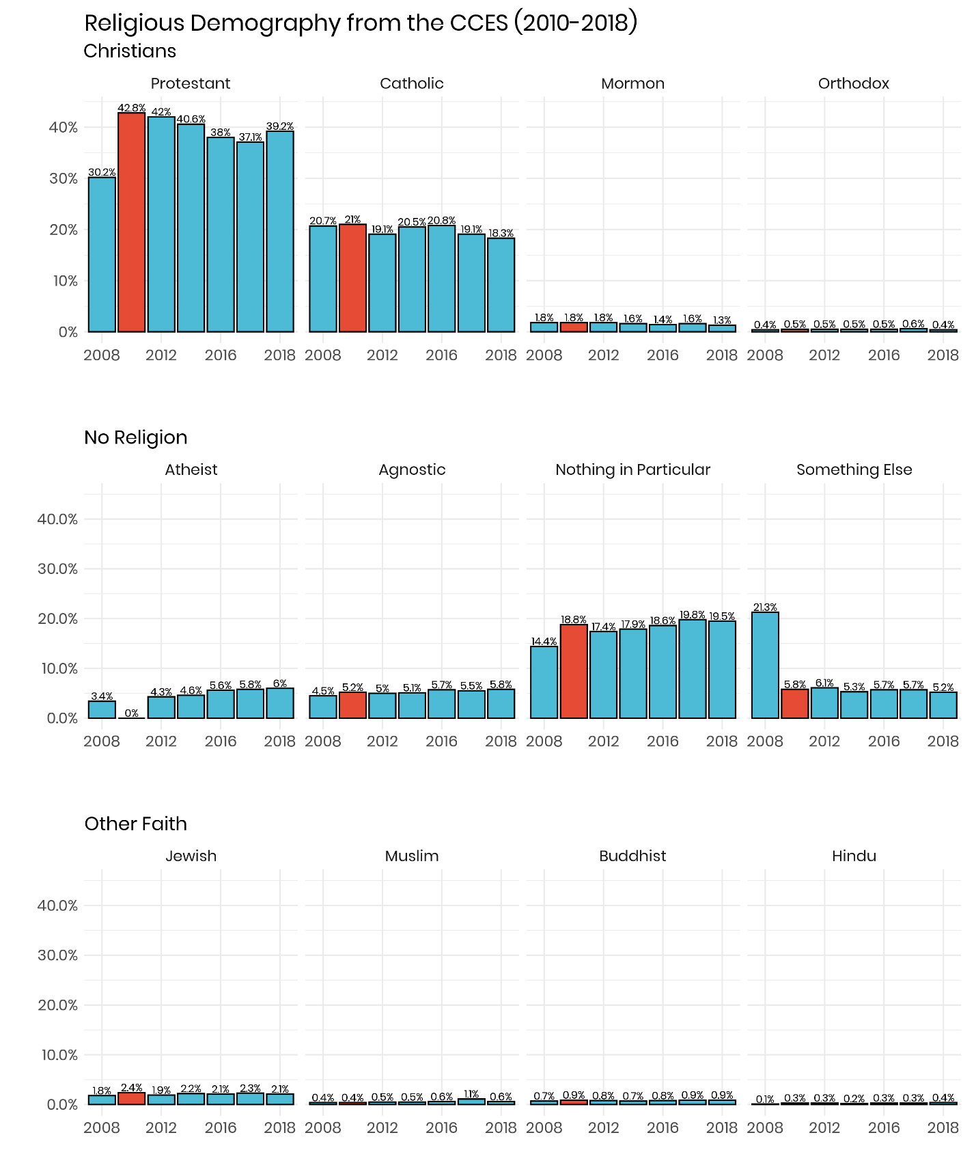

**Religious Importance**

One place to narrow the search for miscategorized atheists would be to look at survey questions where this group would answer them in a distinct way from the rest of the sample. An ideal question is: “How important is religion in your life?” The possible response options range from “very important” to “not at all important.” Atheists are a clear outlier when viewed through this lens with 95.3% of them indicating that religions is not important all, compared to 72.3% of agnostics, and just 16.4% of the entire CCES from 2008-2018. It would helpful to compare the distribution of people who chose “not important at all” in 2010 compared to the other waves. Religious categories that saw a significant rise would be likely places where atheists moved to in 2010.

**Figure 2**

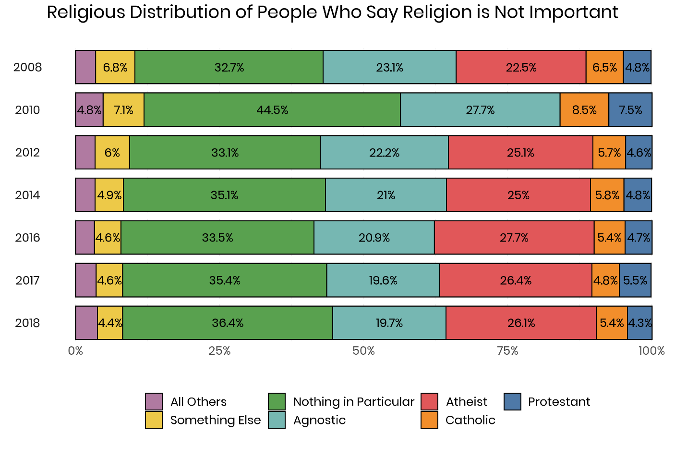

In a typical year, between 22% and 27% of the subsample that says that religion is not important at all chose the atheist option. With that choice missing in the 2010 wave, there are significant shifts when it comes to the distribution of groups. For instance, the nothing in particular group is consistently around 33-34% of this subgroup, but jumped to 40.5% in 2010 – this six percent jump would likely be misplaced atheists. Other groups see smaller increases, for instance agnostics rise just two to three percentage points compared to their typical share. That same increase of two to three points is also evident among Catholics. The rise in Protestants is somewhat larger at around four percentage points. From this view it appears that the majority of atheists chose the nothing in particular option.

**Church Attendance**

One other good place to look for atheists in the 2010 sample is among people who never attend church services. In the entire CCES data, 88.9% of all atheists say that they never go to church compared to 69.5% of agnostics, 7.1% of Protestants and 10.4% of Catholics. As was done in the prior analysis, the samples for each were restricted to just people who never attended services and then the religious tradition was calculated for each of the waves of the CCES.

**Figure 3**

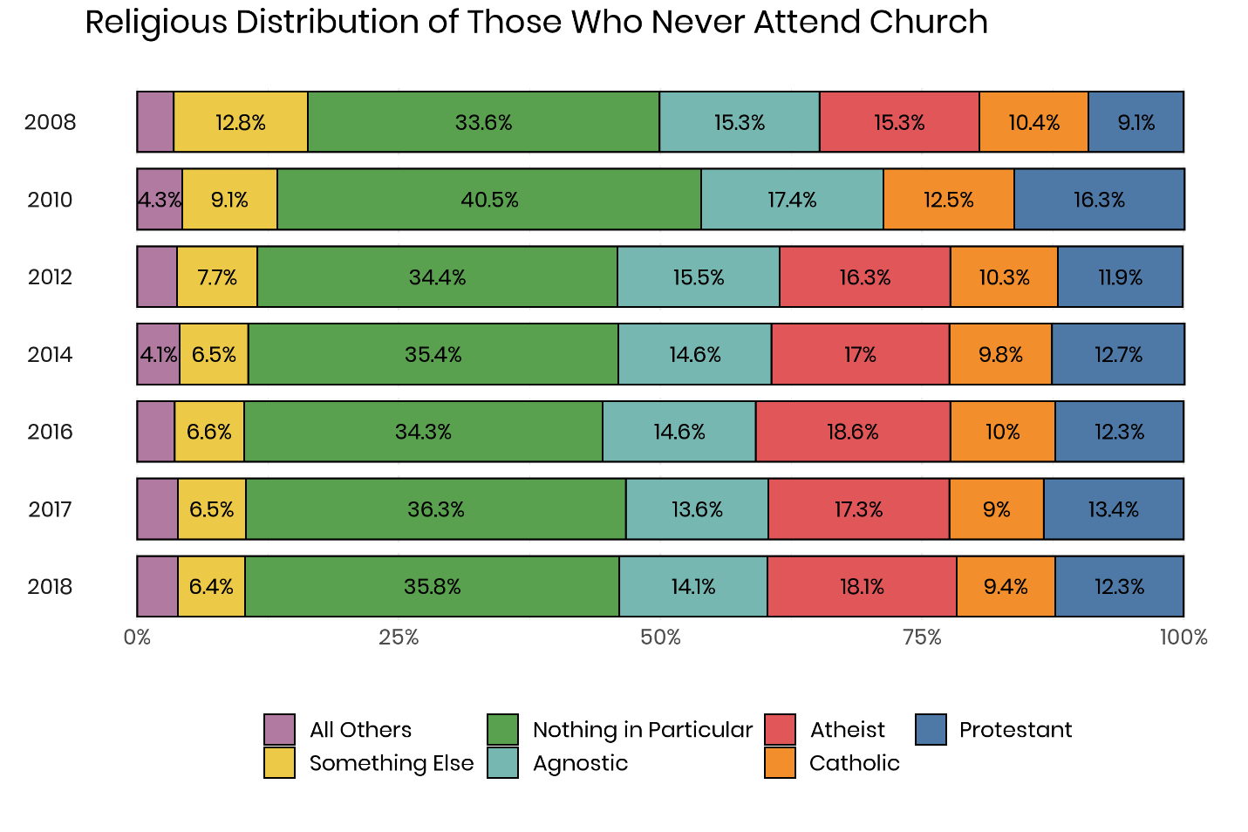

The pattern here is somewhat similar to the analysis that focused on just people who said that religion was not at all important to their lives. The nothing in particular category seems a significant boost in 2010 compared to the other years. Consistently 35% of never attenders identified as nothing in particular, but that rose to 40.5% in 2010. Agnostics also see a small but noticeable increase – from a baseline of 14-15% to 17.4% in 2010. The other noticeable increase is among Protestants. In a typical year about 12% of people who never attend church identify as Protestants, but that increased to 16.3% in 2010 – that’s like because of some atheists who chose the Protestant option.

**Using Machine Learning to Find the Missing Atheists**

One of the most important innovations in the world of statistics and computing in recent years has been the adoption of machine learning methods in all aspects of life. From shopping websites suggesting potential add-on products to a shopping cart, to social media websites recommending new people to friend or follow, artificial intelligence has become part of everyday life for most Americans. It also can be a potential solution to the problem of the misplaced atheists. Many of the most widely adopted algorithms in machine learning are focused on classification. For instance, a company wants to send a coupon to a consumer that is most likely to use that enticement to and make a purchase – identifying these potential customers out of databases containing millions of datapoints by hand would be impractical. However, machine learning can quickly iterate over thousands of possible variables and arrive at a solution that can be constantly refined based on feedback.

The problem that a researcher is confronted with in the 2010 CCES can be approached by using a machine learning technique called random forests. A random forest classifier is based on a simple machine learning principle – a decision tree. A decision tree begins by finding a variable in the data that will divide the sample in the most distinct way possible. The creation of these decision trees occurs millions of times in a random forest model, trying to find an outcome where the trees correctly predict the outcome 100% of the time. To accomplish this, a dataset is divided up into a training dataset and a test dataset. The training dataset has the outcome already labeled. In this case, a dichotomous variable was created for atheists and all other religious traditions. This training data was the 2008 and 2012 CCES waves. To help the random forest make the most accurate guesses a number of variables were included: church attendance, importance of religion, frequency of prayer, born-again status, partisanship, ideology, age, race, gender, education, marital status and income. One of the benefits of random forests is that the algorithm determines which variables are the most important to generating correct guesses and excludes those factors that do not increase the models accuracy.

Using the labeled data from 2008 and 2012, a random forest algorithm was specified that contained a total of 100 trees. The algorithm was able to construct a decision tree that correctly classified atheists in the training data 96.3% of the time.

One of the outputs from a random forest model is a ranking of how important each variable was in terms of its ability to generate predictions that were correct. The variables that the model required on the most were frequency of prayer, religious importance, age, income and church attendance. In general, demographic variables were less helpful to the model, while variables that related to religiosity were particularly valuable. Once, the random forest had been developed using the training data from the 2008 and 2012 CCES, it was then used to predict whether the 55,400 respondents in the 2010 were atheists or not. The result is a score for each respondent ranging from zero (meaning the model predicts that there is no chance that the person is an atheist) to one (which indicates a high probability that the individual identifies as an atheist).

**Figure 4**

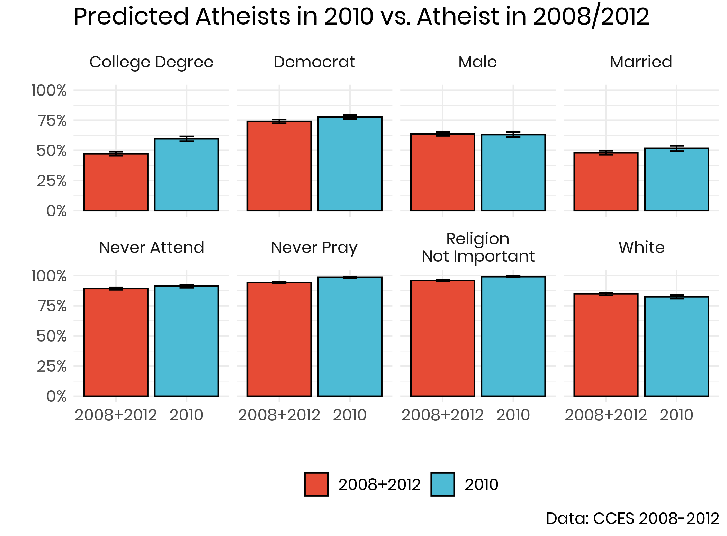

Recall that the expected share of the population that should have chosen an atheist affiliation in 2010 was approximately 3.8%. Therefore, the sample was restricted to those that the algorithm scored with the highest likelihood of being an atheist until 3.8% of the total population was selected. In general, the random forest model was fairly good at creating a sample of predicted atheists in 2010 that looked like those who chose the atheist option in 2008 or 2012. For most of the key variables, there was very little difference between the two groups. In fact, the only variable where the divergence was substantively large was education. In the predicted sample of atheists, 59.6% had a college degree compared to 47.2% of those in 2008 and 2012.

**Figure 5**

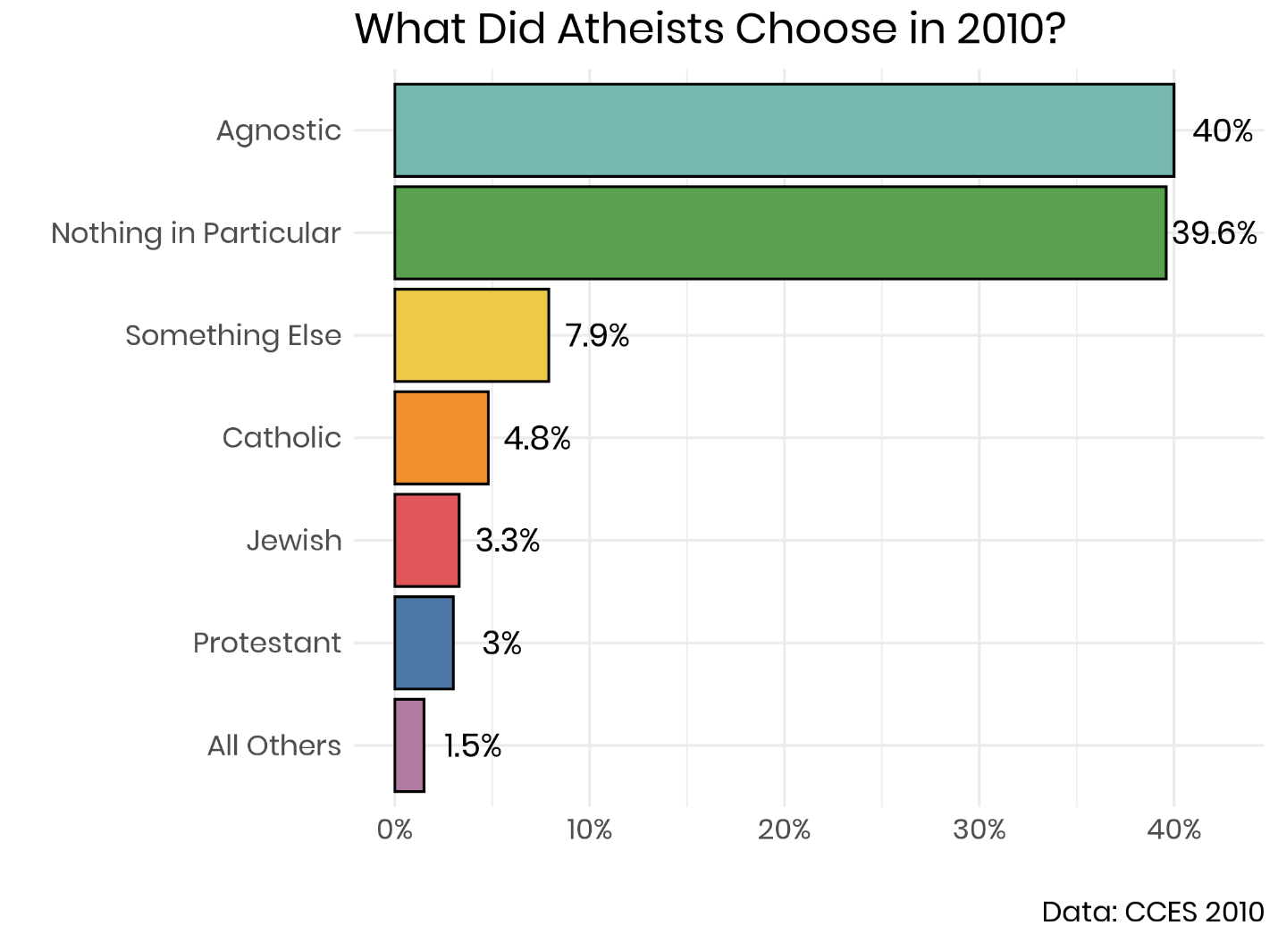

Using those who scored in the highest 3.8% of likelihood to be an atheist using the random forest algorithm, it becomes possible to determine how this share of the population navigated the religious tradition question in 2010. The data tells us a clear story: the vast majority of potential atheists chose another type of religiously unaffiliated tradition. Two out of four chose agnostic, and the same share picked the nothing in particular option. Therefore, the total share of nones was only slightly diminished due to this survey error. It’s worth noting that even though agnostics seemed likely the most likely landing spot for many of these atheists, the data indicates that they were just as likely to pick either of the nones options. It’s also worth pointing out that very of these predicted atheists chose Judaism or Christianity. Recall that there was a slight bump in the share of Jews, Catholics and Protestants in 2010, and that can be somewhat attributed to the fact that between 3.3% and 5% of potential atheists chose one of these options.

Works Cited:

Baker, Joseph and Buster Smith. 2015. *American secularism: Cultural contours of nonreligious*

*belief systems*. NYU Press.

Bellah, Robert N. et al. 2007. *Habits of the Heart, With a New Preface: Individualism and*

*Commitment in American Life*. First Edition, With a New Preface edition. Berkeley, Calif. Los Angeles, Calif. London: University of California Press

Caplow, Theodore. 1998. The Case of the Phantom Episcopalians. *American Sociological*

*Review* 63 (1): 112–113.

Converse, JM. 1986. *Survey Questions: Handcrafting the Standardized Questionnaire*. Beverly

Hills: Sage Publications.

Cragun, R. T. 2016. ‘Defining That Which is “Other to” Religion: Secularism, Humanism,

Atheism, Freethought, etc.’ In: Zuckerman, P (ed.), *Religion: Beyond Religion*, 1–16. New York City: MacMillan Publishing Company (Macmillan Reference USA).

Cragun, Ryan T. 2014. “Who Are the ‘New Atheists’?.” Pp. 195–211 in *Atheist Identities:*

*Spaces and Social Contexts*, edited by Lori Beamon and Steven Tomlins. New York: Springer.

Cragun, R.T., 2019. Questions You Should Never Ask an Atheist: Towards Better Measures of

Nonreligion and Secularity. *Secularism and Nonreligion*, 8, p.6. DOI: <http://doi.org/10.5334/snr.122>

Day, A. 2011. *Believing in Belonging: Belief and Social Identity in the Modern World*. Oxford;

New York: Oxford University Press.

Good, Dorothy. 1959. Questions on Religion in the United States Census. *Population Index* 25

(1): 3–16.

Hadaway, C. Kirk, Penny Long Marler, and Mark Chaves. 1993. What the Polls Don’t Show: A

Closer Look at US Church Attendance. *American Sociological Review* 58 (6): 741–752.

Hadaway, C.Kirk, Penny Long Marler, and Mark Chaves. 1998. Overreporting Church

Attendance in America: Evidence That Demands the Same Verdict. *American Sociological Review* 63 (1): 122–130.

Hall, DE, Koenig, HG and Meador, KG. 2009. ‘Hitting the target: why existing measures of

“religiousness” are really reverse-scored measures of “secularism”’. *Explore (New York, N.Y.)*, 4(6): 368–73. DOI: <https://doi.org/10.1016/j.explore.2008.08.002>

Hall, DE, Meador, KG and Koenig, HG. 2008. ‘Measuring religiousness in health research:

review and critique’ *Journal of Religion and Health*, 47(2): 134–163. DOI: <https://doi.org/10.1007/s10943-008-9165-2>

Hout, Michael. 2017. Religious Ambivalence, Liminality, and the Increase of No Religious

Preference in the United States, 2006–2014. *Journal for the Scientific Study of Religion* 56 (1): 52–63.

Hout, Michael, and Andrew M Greeley. 1987. The Center Doesn’t Hold: Church Attendance in

the United States, 1940–1984. *American Sociological Review* 325–345.

Hout, Michael, and Andrew Greeley. 1998. What Church Officials’ Reports Don’t Show:

Another Look at Church Attendance Data. *American Sociological Review* 63 (1): 113–119.

Hout, Michael, and Claude S. Fischer. 2002. Why More Americans Have No Religious

Preference: Politics and Generations. *American Sociological Review* 67 (2): 165.

Hwang, K, Hammer, JH and Cragun, RT. 2011. ‘Extending Religion-Health Research to

Nontheistic Minorities: Issues and Concerns’. *Journal of Religion and Health*, 50(3): 608–22. DOI: <https://doi.org/10.1007/s10943-009-9296-0>

Kohut, Andrew, John C. Green, Scott Keeter, and Robert C. Toth. 2001. *The Diminishing*

*Divide: Religion’s Changing Role in American Politics*. Washington: Brookings Institution Press.

Kosmin, BA, et al. 2009. *American Nones: The Profile of the No Religion Population*. Hartford,

CT: Institute for the Study of Secularism in Society and Culture, 29.

Lee, L. 2014. ‘Secular or nonreligious? Investigating and interpreting generic “not religious”

categories and populations’. *Religion*, 44(3): 466–482. DOI: <https://doi.org/10.1080/0048721X.2014.904035>

Lim, Chaeyoon, Carol Ann MacGregor, and Robert D. Putnam. 2010. Secular and Liminal:

Discovering Heterogeneity Among Religious Nones. *Journal for the Scientific Study of Religion* 49 (4): 596–618.

Machalek, Richard, and Michael Martin. 1976. ‘Invisible’ Religions: Some Preliminary

Evidence. *Journal for the Scientific Study of Religion* 15 (4): 311–321.

McCafree, Kevin. 2017. *The Secular Landscape: The Decline of Religion in America*. Berlin:

Springer.

Presser, S., and L. Stinson. 1998. Data Collection Mode and Social Desirability Bias in

Self-Reported Religious Attendance. *American Sociological Review* 63 (1): 137–145.

Schnell, T. 2015. ‘Dimensions of Secularity (DoS): An Open Inventory to Measure Facets of

Secular Identities’. *The International Journal for the Psychology of Religion*, 25(4): 272–292. DOI: <https://doi.org/10.1080/10508619.2014.967541>

Schwadel, Philip. 2020. "The Politics of Religious Nones." *Journal for the Scientific Study of*

*Religion*, 59(1).

Smith, Tom W. 1991. Counting Flocks and Lost Sheep: Trends in Religious Preference since

World War II. *GSS Social Change Report* 26: 40–42.

Smith, Tom W., and Seokho, Kim. 2005. The Vanishing Protestant Majority. *Journal for the*

*Scientific Study of Religion* 44 (2): 211–223.

Smith, Tom W., and Seokho, Kim. 2007. C*ounting Religious Nones and Other Religious*

*Measurement Issues: A Comparison of the Baylor Religion Survey and General Social Survey*. GSS Methodological Report No.110:17.

Swatos, William H., and Kevin J. Christiano. 1999. Secularization Theory: The Course of a

Concept. *Sociology of Religion* 60 (3): 209–228.

Svalastoga, Kaare. 1965. *Social Differentiation*. New York: D. McKay Co.

Vernon, Glenn M. 1968. The Religious “Nones”: A Neglected Category. *Journal for the*

*Scientific* *Study of Religion* 7 (2): 219–229.

Weber, M. 2002. *The Protestant Ethic and the “Spirit” of Capitalism and Other Writings*. New

York: Penguin Group USA.

Woodberry, Robert D. 1998. When Surveys Lie and People Tell the Truth: How Surveys

Oversample Church Attenders. *American Sociological Review* 63 (1): 119–122.

Yinger, J.Milton. 1969. A Structural Examination of Religion. *Journal for the Scientific Study of*

*Religion* 8 (1): 88–99.

Zuckerman, Phil, Luke W. Galen, and Frank L. Pasquale. 2016. T*he Nonreligious:*

*Understanding Secular People and Societies*. New York: Oxford University Press.